**RESEARCH THEME: IT System Acceptance in UK Universities**

For this given Research theme, I have written the research philosophy, research approach taken, research methodology used, research strategy, and the research design in detail with explanations.

**RESEARCH PHILOSOPHY: PRAGMATISM**

Pragmatism prioritizes using a pragmatic perspective and utilizing the most effective tools to examine phenomena. I choose to use a pragmatic approach by utilizing a range of research methodologies, such as surveys, interviews, and observations, to collect data on the factors that influence the acceptance of IT systems. A pragmatic approach enables researchers to adapt their methodologies and interpretations in response to the changing characteristics of the data and situation.

**RESEARCH APPROACH: DEDUCTIVE (Top-Down):**

**Theories/hypothesis Analyse data Hypotheses Supported or not**

**(specific level of focus) (Analysis) (specific level of focus)**

* Deductive reasoning entails starting with a general idea or hypothesis and subsequently subjecting it to analysis through specific observations or evidence.
* Students may initiate the study of IT system adoption by utilizing pre-existing theories.
* Deductive reasoning is a methodical research methodology in which researchers formulate assumptions based on existing knowledge and then collect and analyze data systematically to prove or refute these ideas.
* Researchers investigating the adoption of IT systems may employ a well-defined research design that incorporates explicit hypotheses, variables, and data collection procedures to ensure the study's rigor and validity.

**RESEARCH METHODOLOGY: MIXED METHOD**

* Qualitative: Interviews
* Quantitative: Survey

The survey questions largely employ quantitative methods, with a focus on collecting numerical data regarding the participants' experiences and perceptions. The interview questions are qualitative, to explore specific elements of the participants' experiences and perspectives in more detail. The interviews yield qualitative data that can explain the quantitative findings by offering contextual information and insights into the underlying causes of specific trends or patterns.

**CASE STUDY: COLLECTIVE**

A collective case study technique would be suitable for researching the IT systems Acceptance in UK universities. This methodology includes using multiple cases to examine a phenomenon. This involves exploring the acceptance of IT systems in several UK universities to comprehend the phenomenon in different educational environments.

**RESEARCH DESIGN:**

**Explanatory Sequential Design:**

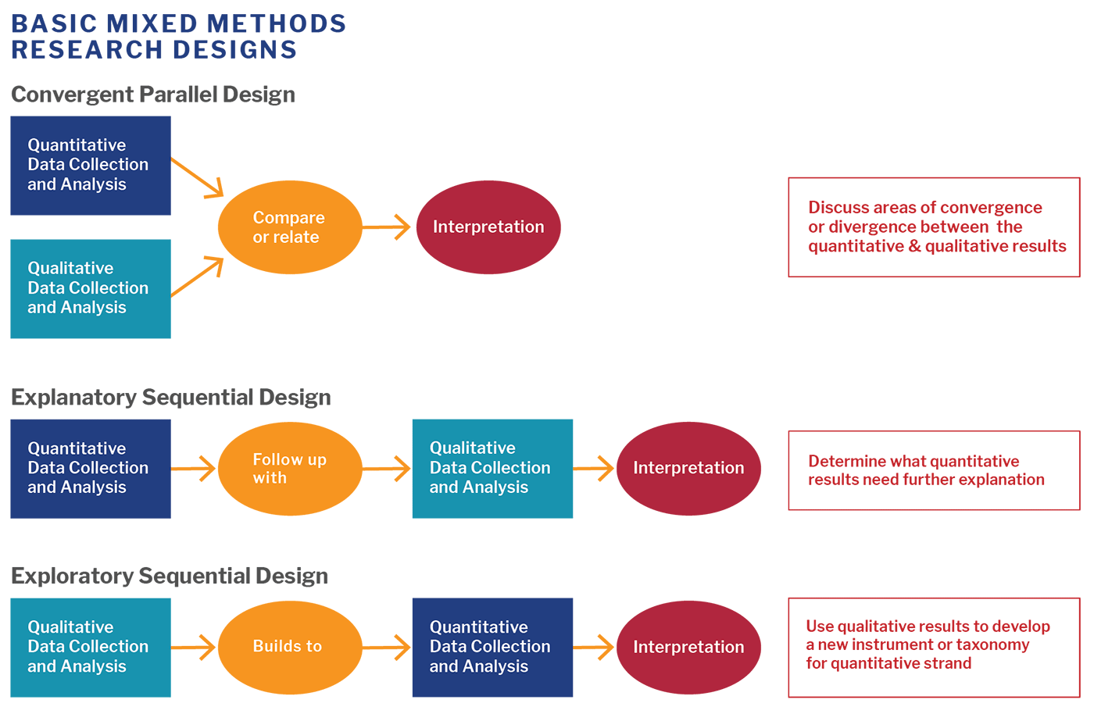

The survey questions are mostly quantitative, and the main goal is to get numbers to show how the participants feel and what they know about IT systems in UK universities. This quantitative data can show how common certain experiences and views were among the people who took the survey.   
  
After collecting and analyzing quantitative data, the interview questions are qualitative and are meant for particular aspects of the responses and their perspectives view. The conversations gave us qualitative data that can help explain the quantitative results in more depth by giving us context and clues about why certain trends or patterns we saw in the quantitative data happened.

In this case, the sequential explanatory mixed methods approach is used to get an extensive understanding of how IT systems are used and perceived in UK universities.